**CS/MATH 111 Quiz 1 Responses**

**Ivan Neto**

Problem 1:

a)

b) not enough time

Problem 2:

a)

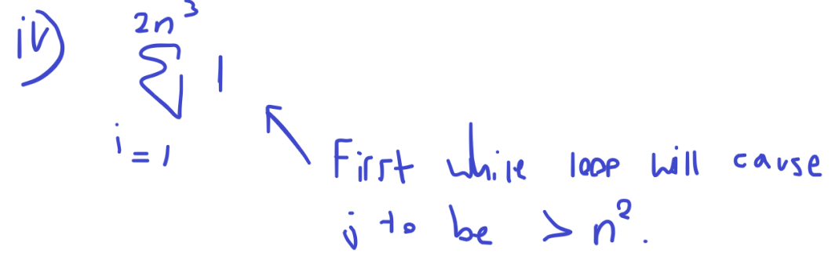

b)

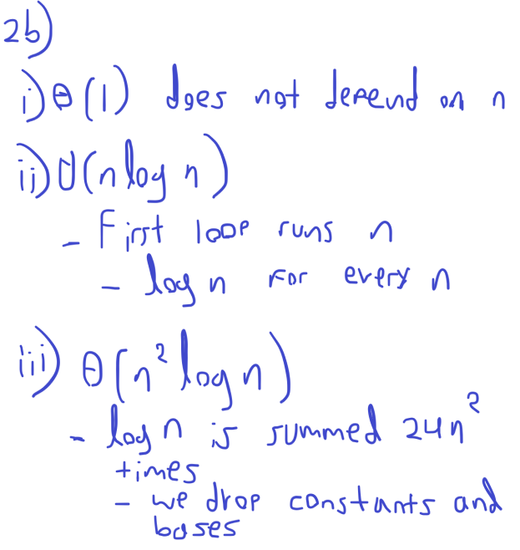

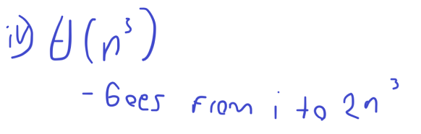

Problem 3:

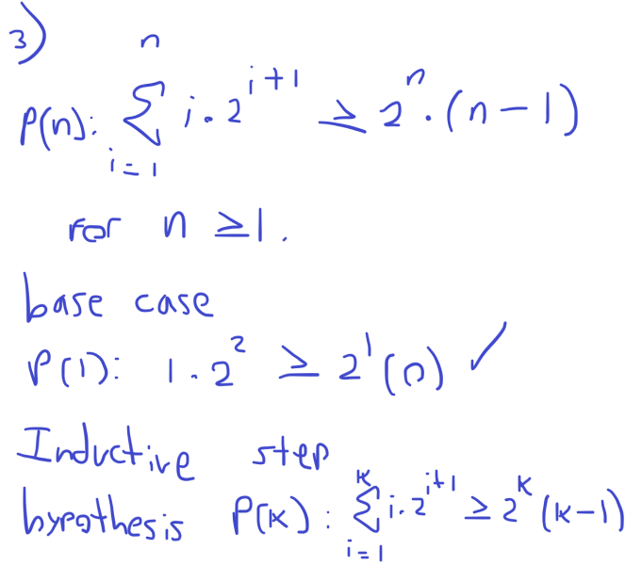

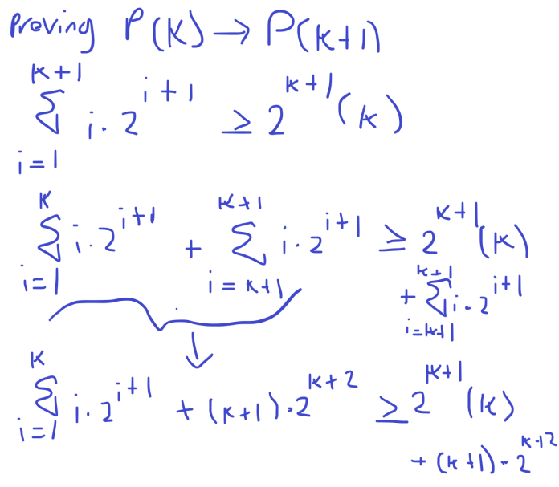

* Not enough time for steps after